**Introduction**

In this hands-on lab, we will use Kinetis Design Studio to build and run the http server example.

**Resources**

PC running Windows 7 with the following software:

• Kinetis Design Studio (KDS) v2.0.0

• MQX for KSDK v1.1.0

Hardware:

• FRDM-K64F

1. **Build MQX Working Set**
   1. Open KDS



* 1. Set any workspace directory and click on OK.

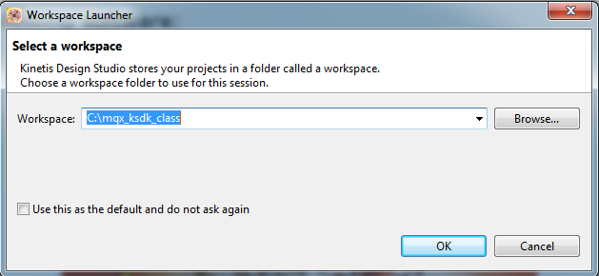

* 1. Click on the “Workbench” icon to go to the main Workbench screen. This only has to be done the first time a new workspace location is used.



* 1. Import the MQX libraries working set. A working set is a collection of Eclipse projects. Use the menu **File->Import**.
  2. Under the MQX group, select **Import Working Sets**. Then click ‘Next’.

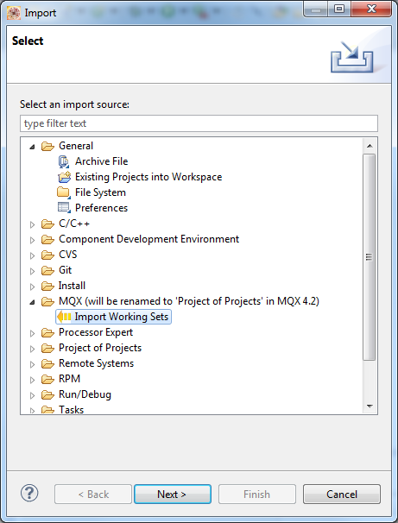

* 1. Browse to the MQX for KSDK directory **"*C:\Freescale\KSDK_1.1.0\rtos\mqx\build\kds\workspace_frdmk64f\build_libs.wsd*"**This imports the MQX libraries used by MQX applications.

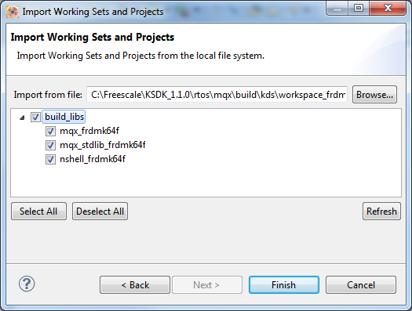

* 1. Import the rtcs_frdmk64f project located in **"*C:\Freescale\KSDK_1.1.0\tcpip\rtcs\build\kds*"** and compile the project.

1. **Build KSDK MQX Library**
   1. Next import the KSDK MQX library. This library is not part of the MQX working set. This time we will import a single project instead of a working set. Use the KDS menu **File->Import**.

Note: If the Working Set plugin was not installed on your version of KDS, you could instead import each of the MQX libraries individually using the steps in this section.

* 1. In the General group, select **Existing Projects into Workspace**.

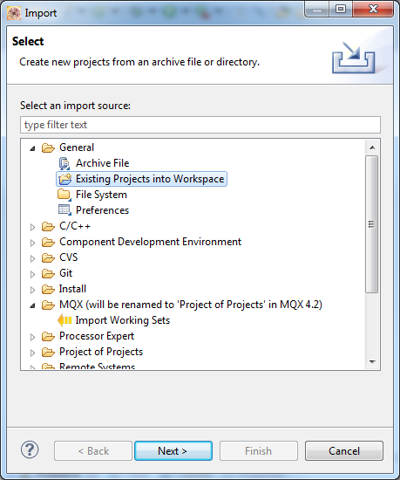

* 1. Browse to the root directory ***C:\Freescale\KSDK_1.1.0\lib\ksdk_mqx_lib\kds\K64F12***.
  2. Select the project **ksdk_mqx_lib_K64F12**. Click ‘Finish’.

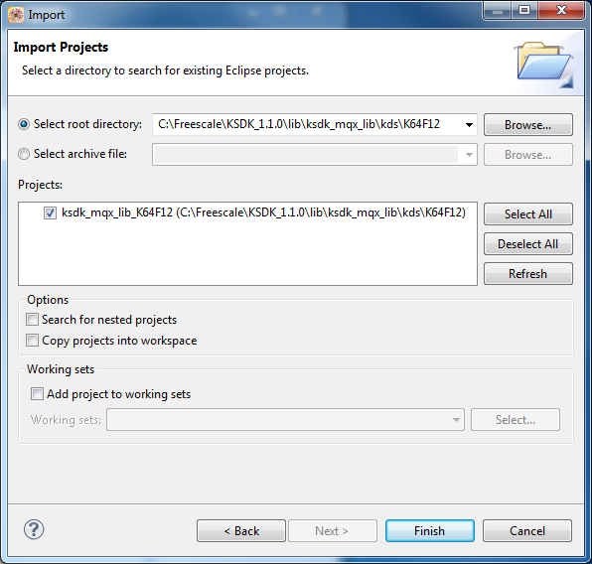

NOTE: Never check the box labeled “Copy projects into workspace” when importing KSDK or MQX projects. This will cause issues finding files when building the projects.  
  
The following projects are now imported in the workspace  
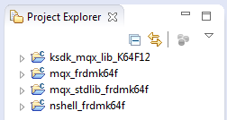

* 1. Build all the projects in the workspace. These can all be built together. Use the KDS menu **Project->Build All**.

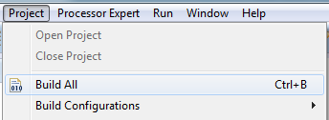

Note: You can go to the Console tab at the bottom to see the status of the build and any errors that may come up

1. **Import http server example**
   1. Import a project, using the **File->Import->General->Existing Projects into Workspace**. Browse to the project directory and import **rtcs_frdmk64f** project ***C:\Freescale\KSDK_1.1.0\tcpip\rtcs\build\kds*** and compile the project.
   2. Import a project like before, using the menu **File->Import->General->Existing Projects into Workspace**. Browse to the project directory and import **httpsrv_frdmk64f** project ***C:\Freescale\KSDK_1.1.0\tcpip\rtcs\examples\httpsrv***
   3. Build a single project this time. In the Project Explorer View, select the project httpsrv_frdmk64f.

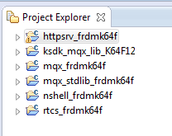

* 1. Build the application by clicking the **pull-down arrow** to the right of the Hammer icon on the upper toolbar. Then select the **Int Flash Debug** target. The Problems View should show no errors, and the Console View should show the application built.

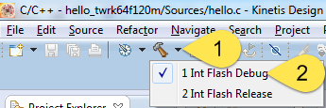

* 1. Now plug the USB cable to the FRDM-K64F board. Connect to the mini-USB connector labeled “SDA USB”. The board should have the JLink OpenSDA app loaded. Windows may need some time to load the driver.
  2. Find the COM port for the OpenSDA serial connection. Windows Device Manager will show the COM number under the Ports (COM & LPT) group. Here, the COM port is 5.  
     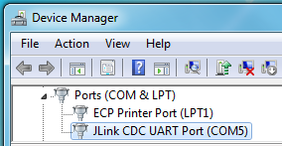
  3. Go to windows Control Panel and click on Network and Internet.

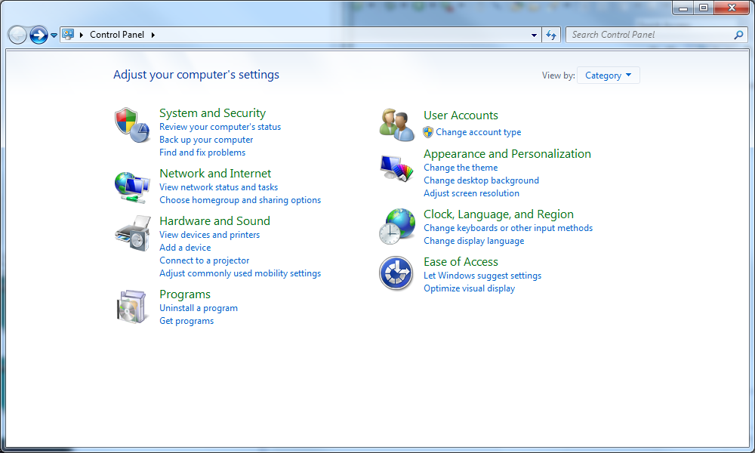

* 1. Click on Network and Sharing Center.

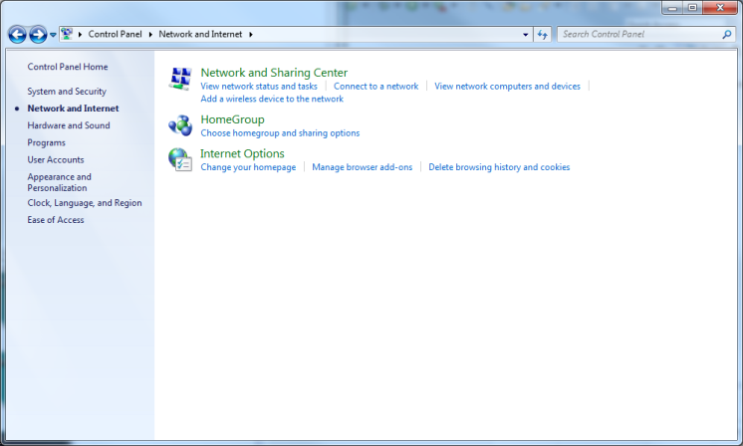

* 1. Click on change adapter settings

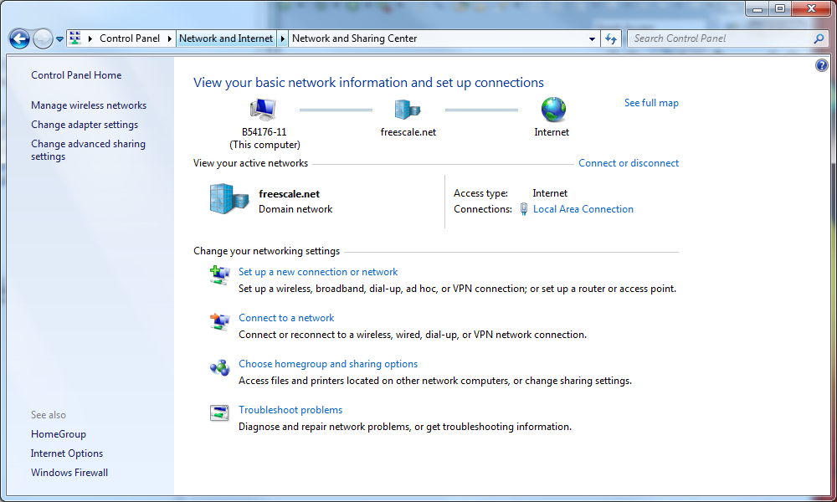

* 1. Connect your board to your computer with an Ethernet cable.
  2. Right click on Local Area Connection and click Properties.

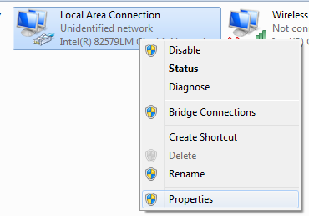

* 1. Double click on Internet Protocol Version 4 (TCP/IPv4)
  2. Click on Use the following IP address and insert a similar one to the one in config.h

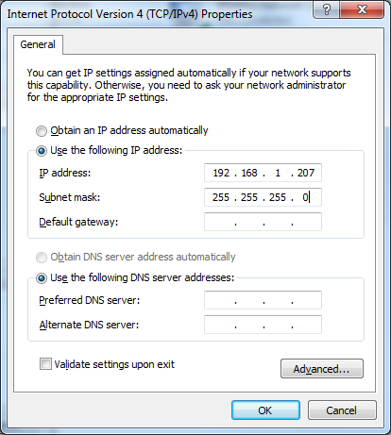

* 1. After doing that go to the KDS project and debug and resume your program.
  2. Go to your internet browser and insert the IP address that is on config.h



You will see the following web page that is hosting your MCU.

